COURSE NAME: Theory of Computation COURSE CODE: CSA1304

COURSE OUTCOME COVERED

CO2: Deign Finite Automata DFA, NFA, ε-NFA and demonstrate their equivalence for recognizing regular languages. (BL:3)

Assessment Tool Weightage: 40%

QUESTIONS: 5 Total Marks:25
Duration : 1 Hour

Design Task

Code of Conduct:

I SRIVARSHA M – 192371010 (Name / Reg No) certify that this submission is my original work and that I have adhered to the guidelines specified for this assessment.
I understand that any violation of academic integrity rules will result in disciplinary action.

Signature of the student: SRIVARSHA M

- Design the regular expression for the language represented by the given automata
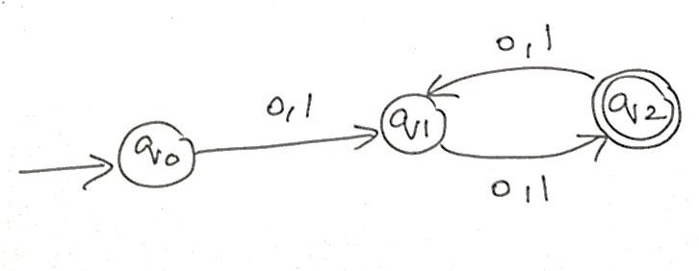
- Consider the following grammar S->aSc|T|U|e
T-> bTc|e U->aUb|e
A} What is the language defined by the grammar?
- Give the derivation tree for the word aaabbc
- A Grammar is Ambiguous if there exists two distinct derivations for a word. Is the above grammar ambiguous? Justify.

- Design a non deterministic finite automata with ε-transitions to represent the language denoted by the regular expression
00*1+11*0
- I)Show that if L1 and L2 are regular then (L1+l2) also regular Ii)Is the language { a^p| p is prime} regular? Justify

- Design minimized automata, Consider the DFA given below. Find the states that are equivalent and construct a minimum state automata equivalent to the given automata. Draw the minimized automata, write its transition table and mark initial and final states
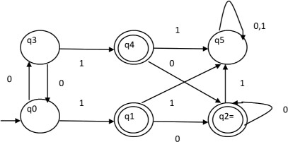

Question 1 — Regular Expression for the Given Automaton
The given automaton has three states: q0 (start), q1, and q2 (final state). The transitions are as follows:
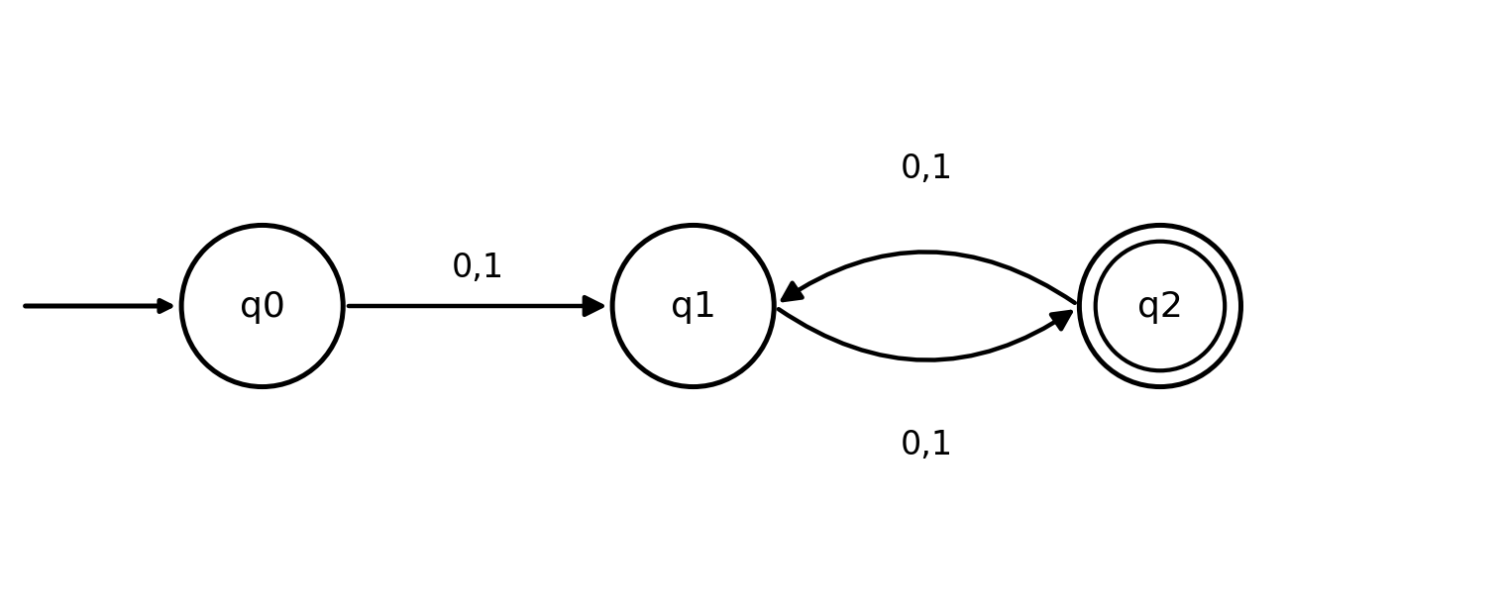
Fig 1.1 — Given finite automaton
- q0 → q1 on input 0 or 1
- q1 → q2 on input 0 or 1
- q2 → q1 on input 0 or 1
Analysis: Starting at q0, exactly one symbol (0 or 1) is needed to reach q1. From q1, the automaton oscillates between q1 and q2 with every additional symbol, and q2 (the only final state) is reached after an even number of transitions from q0.
Therefore, the automaton accepts all strings over {0,1} whose length is even and at least 2 — i.e., pairs of symbols, repeated any number of times.
Regular Expression:
R = (0+1)(0+1) [ (0+1)(0+1) ]*
Equivalently, this can be written as R = ((0+1)(0+1))+ , representing one or more blocks of two symbols from {0,1}.
Question 2 — Grammar Analysis
S → aSc | T | U | ε
T → bTc | ε
U → aUb | ε
(A) Language defined by the grammar
T generates equal numbers of b's and c's: T ⇒ bʲcʲ for j ≥ 0.
U generates equal numbers of a's and b's: U ⇒ aᵏbᵏ for k ≥ 0.
S wraps i copies of 'a' and 'c' around T or U (or ε):
- Via ε: S ⇒ aⁱcⁱ (equal a's and c's, no b's)
- Via T: S ⇒ aⁱ(bʲcʲ)cⁱ = aⁱbʲc⁽ⁱ⁺ʲ⁾ → here (count of c) = (count of a) + (count of b)
- Via U: S ⇒ aⁱ(aᵏbᵏ)cⁱ = a⁽ⁱ⁺ᵏ⁾bᵏcⁱ → here (count of a) = (count of b) + (count of c)
So, in general, for a string aᵐbⁿcᵖ (m,n,p ≥ 0):
L(S) = { aᵐ bⁿ cᵖ | p = m+n OR m = n+p }
In words: the language consists of strings of a's followed by b's followed by c's, where the count of symbols on one 'end' (a's or c's) equals the sum of the counts of the other two symbol groups.
(B) Derivation tree for aaabbc (a³b²c¹)
Check which branch produces m=3, n=2, p=1: Testing the U-branch condition m = n + p → 3 = 2 + 1 ✓ (matches). The T-branch condition p = m+n → 1 = 5 is false, so this string is generated only through the U-branch, with i = 1 (outer a/c pair) and k = 2 (inner U recursions).
Leftmost derivation:
S ⇒ aSc ⇒ aUc ⇒ aaUbc ⇒ aaaUbbc ⇒ aaabbc (U → ε at the last step)
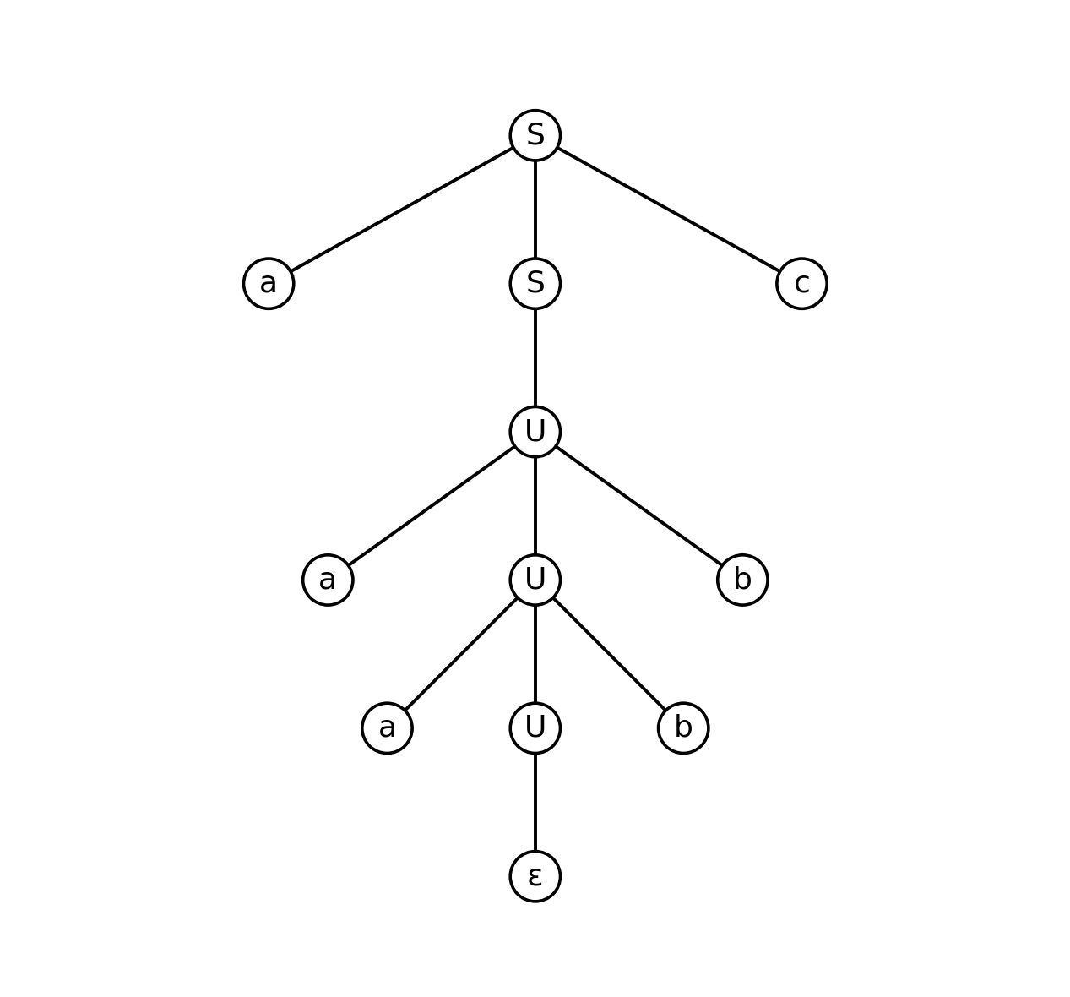
Fig 2.1 — Derivation tree for the string aaabbc
(C) Is the grammar ambiguous? Justification
Yes, the grammar is ambiguous. Although the string aaabbc itself has only one derivation (shown above), the grammar as a whole produces some strings in two structurally distinct ways.
Consider any string of the form aⁿcⁿ (i.e., n=0 b's, so m = p). This satisfies BOTH branch conditions simultaneously: the T-branch (with j = 0, so T ⇒ ε) and the U-branch (with k = 0, so U ⇒ ε) both yield exactly aⁿcⁿ.
Example — for the string 'ac' (n = 1):
Derivation 1: S ⇒ aSc ⇒ aTc ⇒ a(ε)c = ac [uses production S → T]
Derivation 2: S ⇒ aSc ⇒ aUc ⇒ a(ε)c = ac [uses production S → U]
These are two distinct derivation trees (and distinct parse structures) for the identical string 'ac'. Since a single string has more than one derivation tree, the grammar is ambiguous by definition.
Question 3 — ε-NFA for 00*1 + 11*0
The regular expression 00*1 + 11*0 is a union of two sub-expressions: 00*1 (one or more 0's followed by a single 1) and 11*0 (one or more 1's followed by a single 0). We build an ε-NFA by constructing a small machine for each sub-expression and joining them at a common start state using ε-transitions (Thompson's construction, union rule).
Construction:
- New start state q0 has ε-transitions to the start of each branch (qA0 for 00*1, and qB0 for 11*0).
- Branch A (00*1): qA0 —0→ qA1, qA1 has a self-loop on 0 (for 0*), then qA1 —1→ qAf (final).
- Branch B (11*0): qB0 —1→ qB1, qB1 has a self-loop on 1 (for 1*), then qB1 —0→ qBf (final).
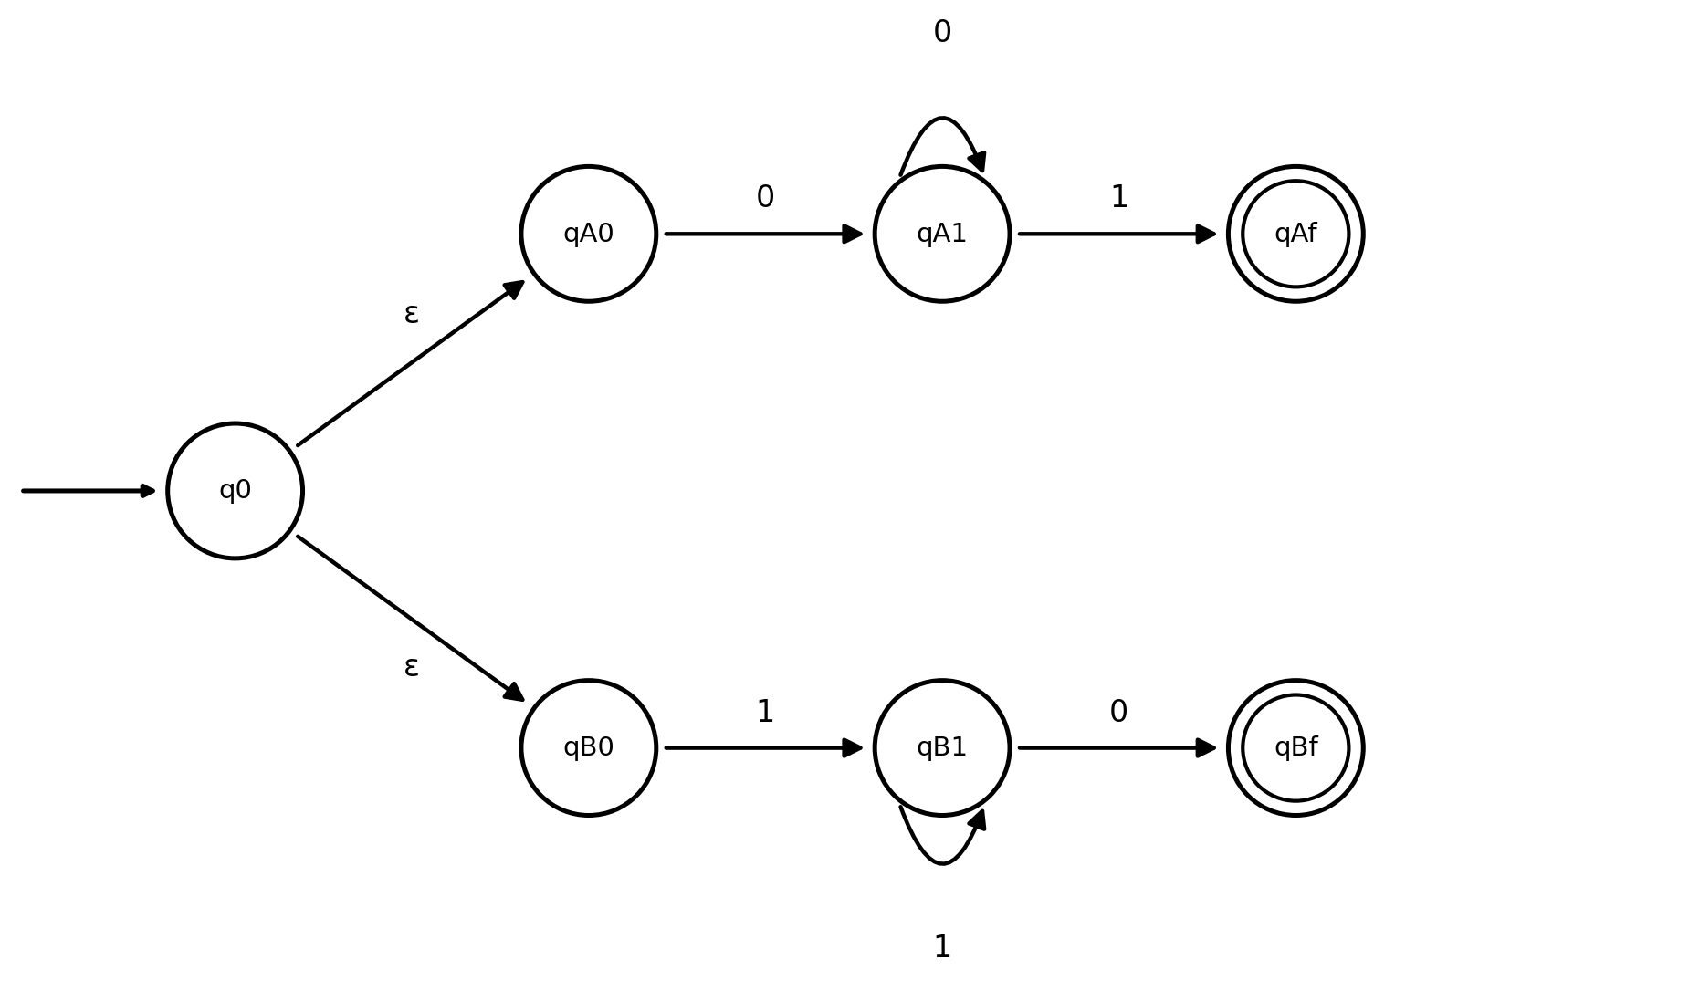
Fig 3.1 — ε-NFA recognizing L = 00*1 + 11*0
Formal definition: M = (Q, Σ, δ, q0, F) where Q = {q0, qA0, qA1, qAf, qB0, qB1, qBf}, Σ = {0,1}, F = {qAf, qBf}, and δ is as shown in the diagram above (including the two ε-transitions from q0).
Question 4
(i) Show that if L1 and L2 are regular, then L1 + L2 is also regular
Proof (by construction): Since L1 and L2 are regular, there exist DFAs M1 = (Q1, Σ, δ1, s1, F1) accepting L1 and M2 = (Q2, Σ, δ2, s2, F2) accepting L2.
Construct a new NFA with ε-transitions, M = (Q1 ∪ Q2 ∪ {q0}, Σ, δ, q0, F1 ∪ F2), where q0 is a new start state with ε-transitions to both s1 and s2, and all other transitions are inherited unchanged from M1 and M2.
On any input string w, M can reach an accepting state if and only if M1 accepts w (via the ε-move to s1) or M2 accepts w (via the ε-move to s2). Hence L(M) = L1 ∪ L2 = L1 + L2.
Since every ε-NFA has an equivalent DFA (by the subset construction), L1 + L2 is accepted by some DFA, and is therefore regular.
Alternative construction (product automaton, no ε required): Define M' = (Q1 × Q2, Σ, δ', (s1,s2), F') with δ'((p,q),a) = (δ1(p,a), δ2(q,a)) and F' = {(p,q) : p ∈ F1 or q ∈ F2}. M' is a DFA that tracks both machines simultaneously and accepts exactly when either component accepts, directly proving closure under union. ∎
(ii) Is the language { aᵖ | p is prime } regular? Justify.
No, this language is not regular. We prove this using the Pumping Lemma for regular languages.
Proof: Suppose, for contradiction, that L = { aᵖ | p is prime } is regular. Then there exists a pumping length n such that every string in L of length ≥ n can be split and pumped.
Since there are infinitely many primes, choose a prime p ≥ n + 2, and let s = aᵖ, so |s| = p ≥ n. By the pumping lemma, s = xyz with |xy| ≤ n, |y| ≥ 1, and xyⁱz ∈ L for every i ≥ 0.
Let |y| = m (1 ≤ m ≤ n). Then |xyⁱz| = p + (i − 1)m for all i ≥ 0. Choose i = p + 1. Then:
|xy^(p+1)z| = p + p·m = p(1 + m)
Since p ≥ 2 and (1 + m) ≥ 2, the length p(1+m) is a product of two integers each greater than 1, so it is composite — not prime. Thus xy^(p+1)z ∉ L, which contradicts the pumping lemma's guarantee that xyⁱz ∈ L for all i ≥ 0.
This contradiction shows our assumption was false. Therefore, { aᵖ | p is prime } is not regular. ∎
Question 5 — DFA Minimization
Given DFA
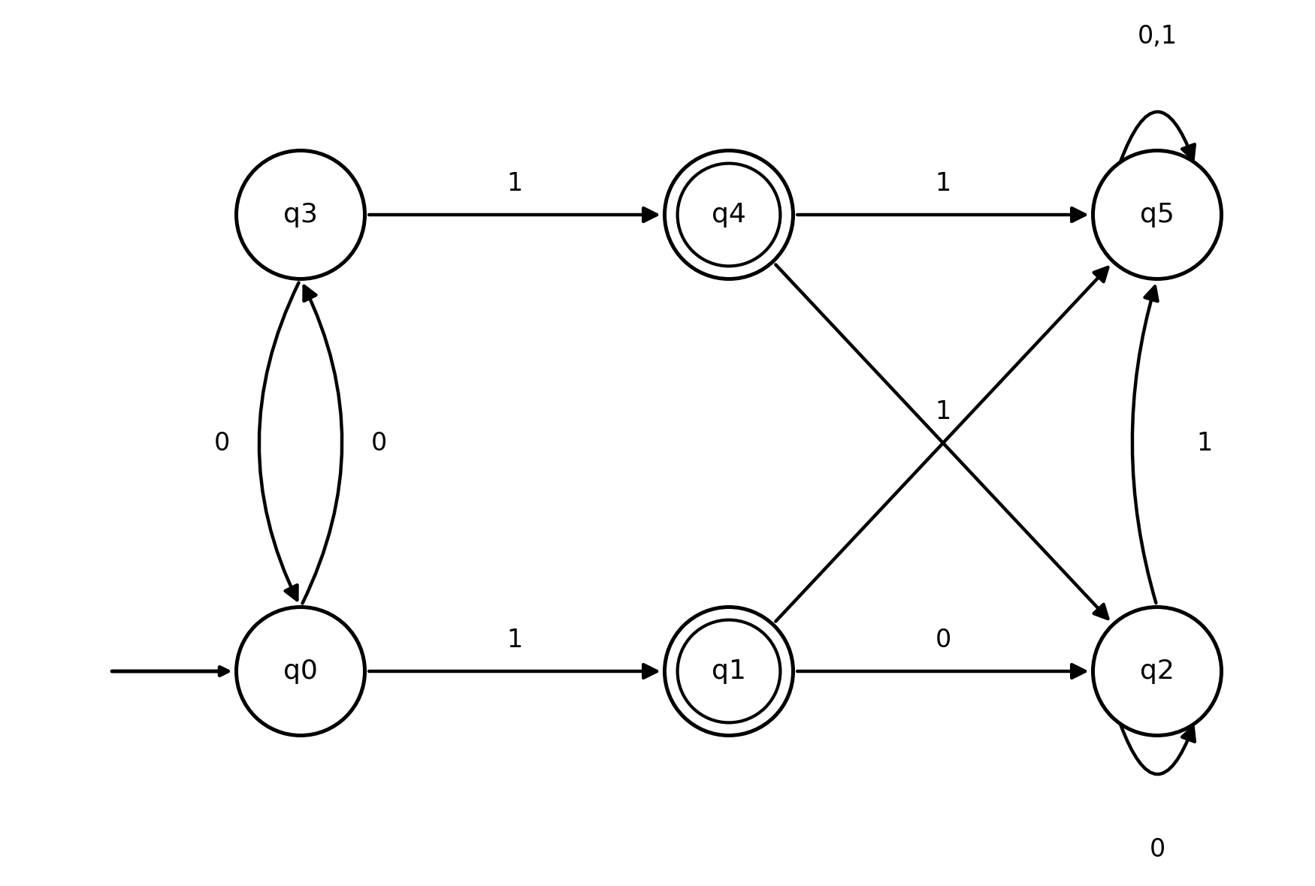
Fig 5.1 — Given DFA (start: q0; final states: q1, q4)
Transition table of the given DFA:
State | 0 | 1 | Final?
→ q0 | q3 | q1 | No
q1 | q2 | q5 | Yes
q2 | q2 | q5 | No
q3 | q0 | q4 | No
q4 | q2 | q5 | Yes
q5 | q5 | q5 | No
Step 1 — Initial Partition
Partition the states by final / non-final status:
P0 = { q1, q4 } (final) { q0, q2, q3, q5 } (non-final)
Step 2 — Refine using transitions (table-filling method)
Check {q1, q4}: on 0, both go to q2 (non-final group); on 1, both go to q5 (non-final group). Same behaviour ⇒ q1 and q4 stay together (equivalent).
Check {q0, q2, q3, q5} on input 1: q0→q1 (final group), q3→q4 (final group), but q2→q5 and q5→q5 (both non-final group). This distinguishes the group — split it:
New partition: { q0, q3 } { q1, q4 } { q2, q5 }
Re-check {q0, q3}: on 0, q0→q3 and q3→q0 — both land in the same class {q0,q3}. On 1, q0→q1 and q3→q4 — both land in {q1,q4}. Consistent ⇒ q0 ≡ q3.
Re-check {q2, q5}: on 0, q2→q2 and q5→q5 — same class {q2,q5}. On 1, q2→q5 and q5→q5 — same class {q2,q5}. Consistent ⇒ q2 ≡ q5.
No further splits occur, so the partition is stable. The equivalence classes are:
Equivalence Class | Merged State Name | Type
{ q0, q3 } | A | Non-final
{ q1, q4 } | B | Final
{ q2, q5 } | C | Non-final
Step 3 — Minimized DFA
Using the equivalence classes as the new states:
State | 0 | 1 | Final?
→ A | A | B | No
B | C | C | Yes
C | C | C | No
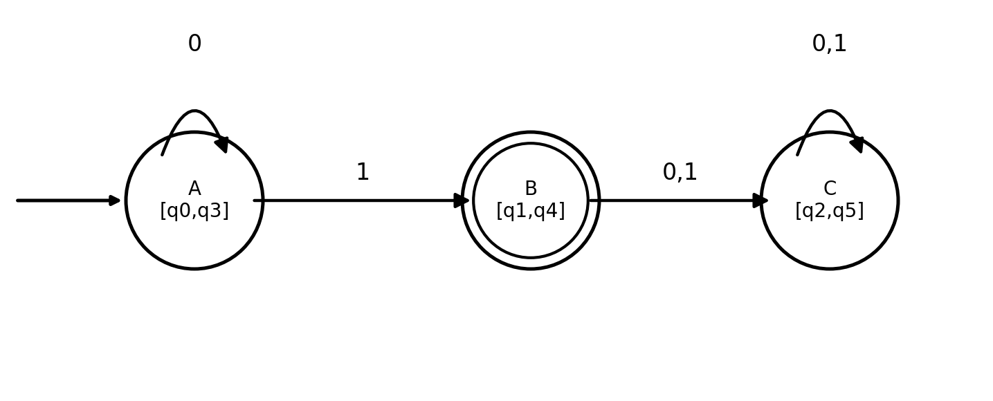
Fig 5.2 — Minimized DFA (3 states: A, B, C)
The minimized DFA has 3 states (reduced from 6), with A = start state, B = the only final state, and C = a non-final trap state. Intuitively, the language accepted is: zero or more 0's followed by exactly one 1 (i.e., 0*1) — any symbol read after that sends the machine into the permanent non-accepting state C.

RUBRICS FOR CALCULATION

Criteria | Weightage | Level 4 –  Exemplary (5 Marks) | Level 3 –  Proficient (4 Marks) | Level 2 –  Developing (2–3 Marks) | Level 1 – Beginning  (0–1 Mark)
Conceptual Understandin g | 30 | Demonstrates clear and complete understanding of  the concept | Good understanding with minor gaps | Basic understanding with some misconceptions | Poor or incorrect understandin g
Accuracy of Answer | 25 | Completely  correct answer with no errors | Mostly correct  with minor errors | Partially correct  with noticeable errors | Incorrect or  irrelevant answer
Application of Knowledge | 20 | Correctly applies concepts to solve the  question/problem | Applies concepts with minor mistakes | Limited or partially correct application | No or incorrect application
Completeness of Response | 15 | Covers all required parts of the question | Covers most parts with minor  omissions | Covers only some parts | Incomplete or missing response
Clarity & Presentation | 10 | Clear, concise, and well-  organized answer | Understandabl e with minor  issues | Somewhat unclear or poorly  structured | Difficult to understand

